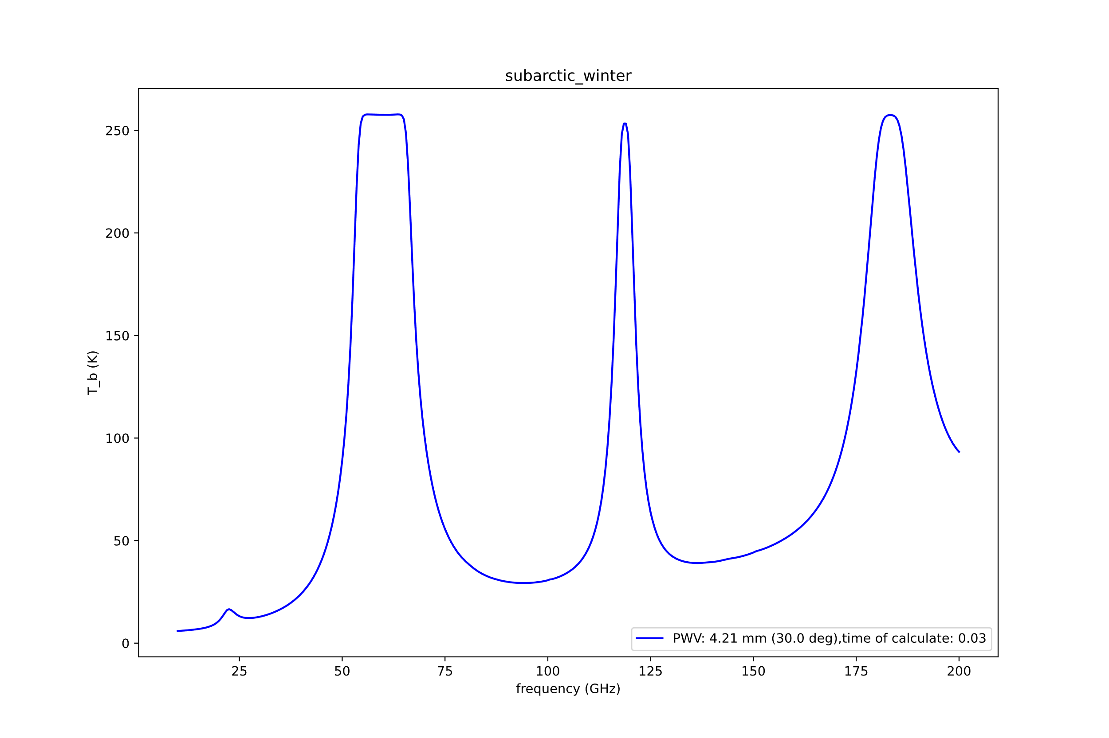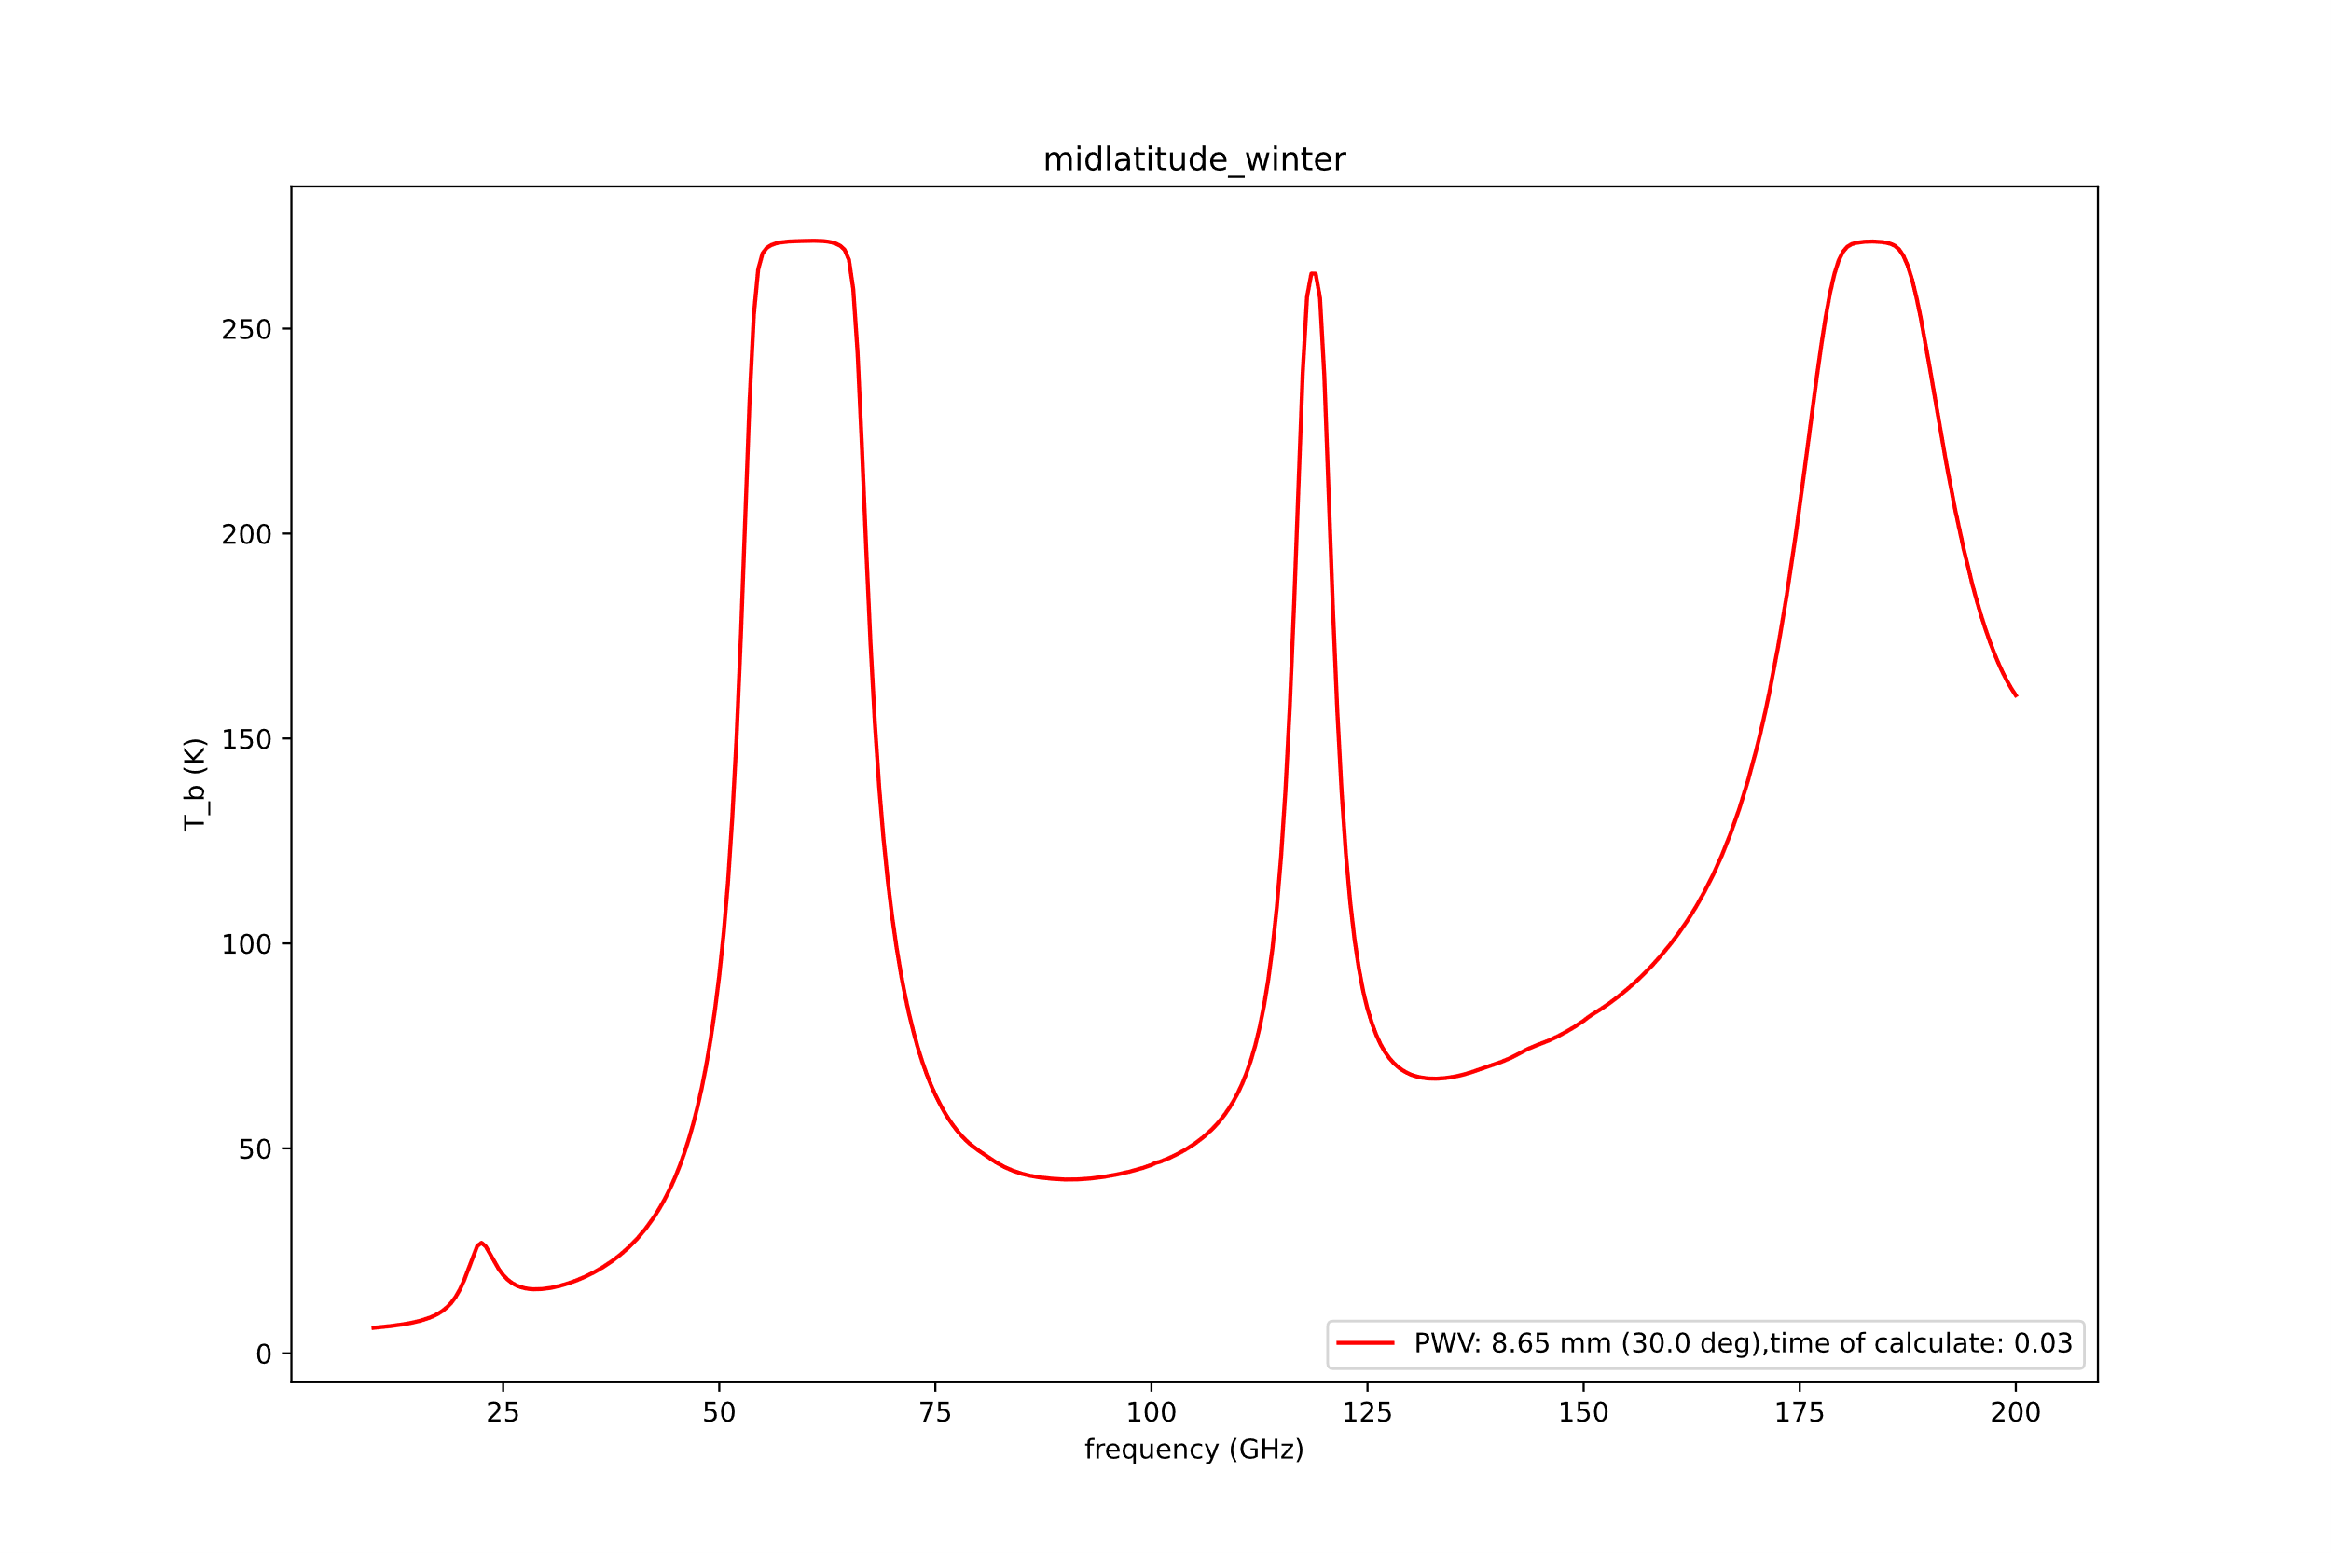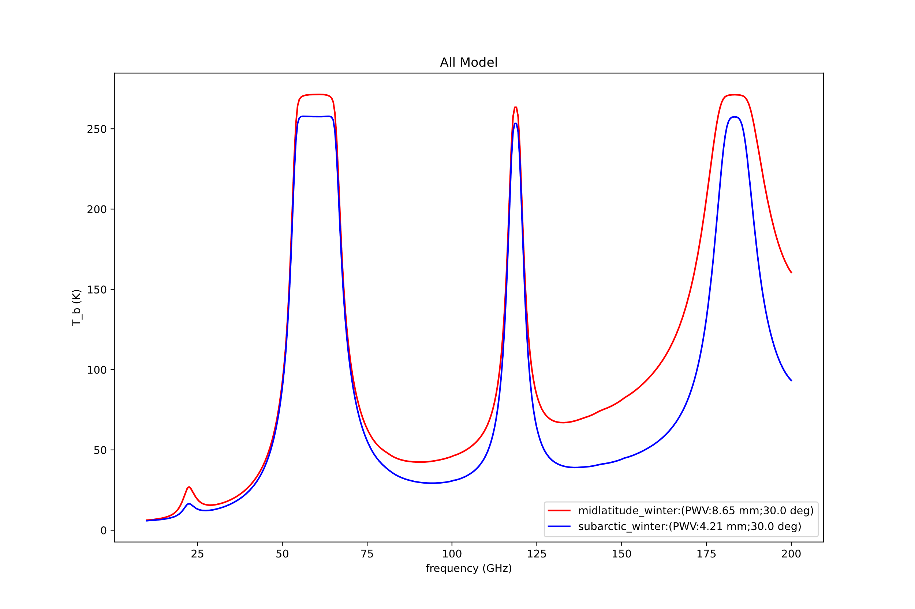

Old code results:

